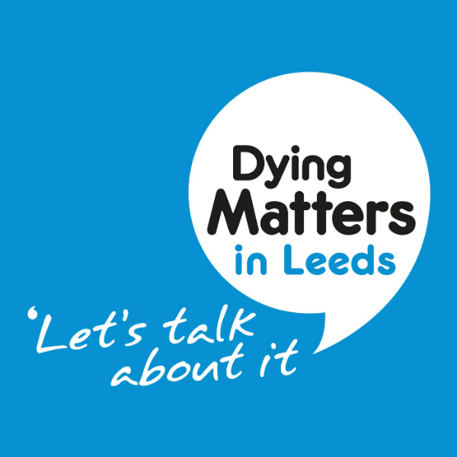
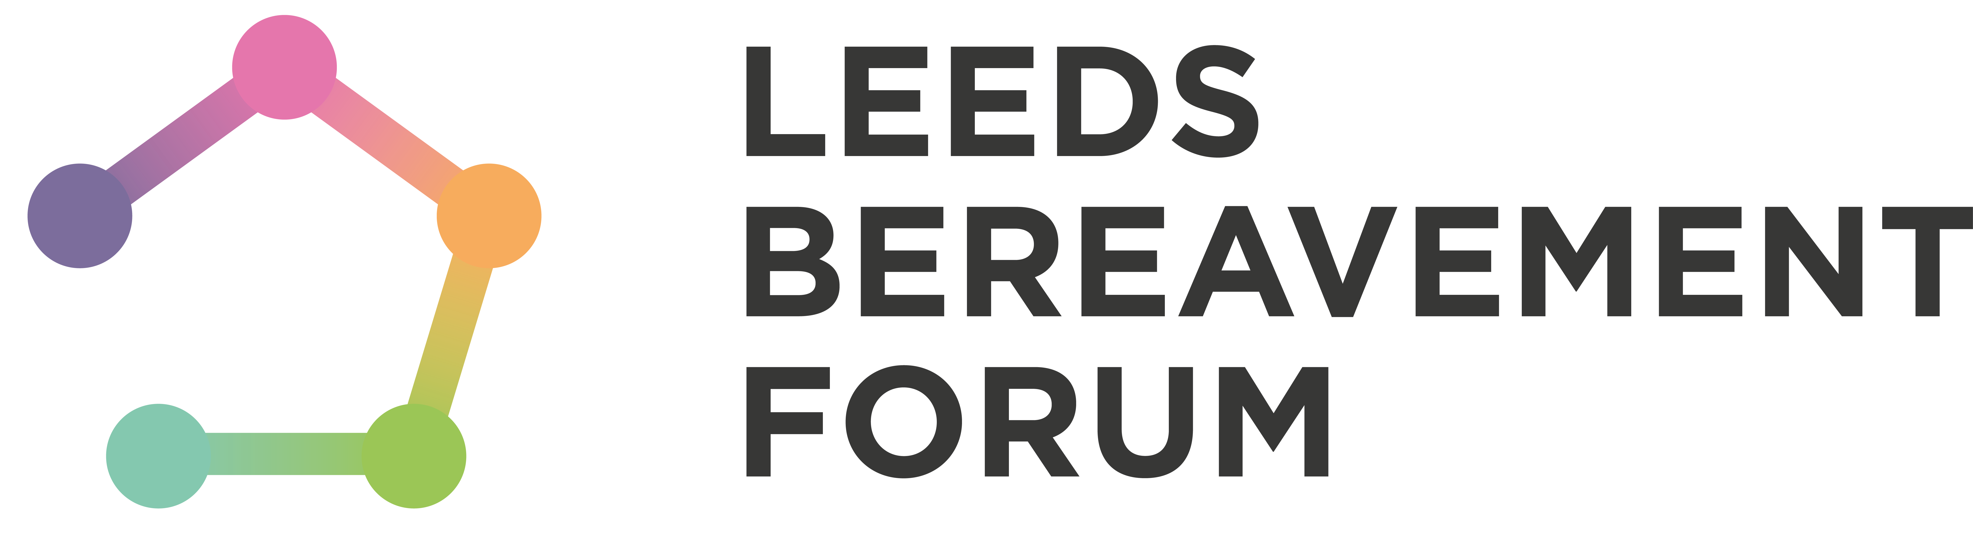

Dying Matters Leeds Community Grant Funding Guidance Notes
Every year in May, Dying Matters Leeds host an Awareness Week, which gives an unparalleled opportunity to place the importance of talking about dying, death and bereavement firmly on the local agenda. This year’s theme is ‘Are We Ready?’ This question aims to challenge everyone on several levels: Are We Ready for our own deaths? Are We Ready for the deaths of those we care about? Are We Ready to help others?’
Dates
Dying Matters Week will run from 13 - 19 May 2019
Dying Matters Leeds Partnership
The Dying Matters Leeds Partnership is a co-ordinated citywide campaign to open the conversation with local communities in Leeds about death, dying and loss and to enable people to plan for the last years of their life.
During Dying Matters Week, we will be encouraging the public to discuss what they want for the end of their lives with those close to them. We will also be encouraging people to take five simple steps to make their end of life experience better, both for them and for their loved ones. These are:
1. Write your will
2. Record your funeral wishes
3. Plan your future care and support
4. Consider registering as an organ donor
5. Tell your loved ones your wishes
Organisations are invited to apply for a Dying Matters Leeds Community Grant of between £50 and £200 to deliver an event in their local community.
Possible events
We are inviting organisations and groups to apply for funding to run an event, which may link to or be inspired by the above themes. A Dying Matters Leeds Awareness Week event can be large, small or anywhere in-between. To give you inspiration, below is a small selection of possible events.
- A coffee morning, with Dying Matters Leeds resources on display
- A display featuring a tree of life graphic on which members of the public could post notes about improving services relating to death and dying
- A series of Death Cafes
- An afternoon of activities, including the screening of Dying Matters films and talks from local bereavement associations and funeral directors
- A Dying Matters arts competition
- A reminiscence session using memory boxes provided by the local museum
What you can apply for:
We recognise that applications are likely to be varied, and encourage creative and innovative ideas that are appropriate to local groups and communities to tie in with the theme of ‘What Can You Do?’
Organisations can apply for anything between £50 and £200 for events held between 13 - 19 May 2019. The audience can be the public, your service users, staff or volunteers. In the spirit of diversity, we would encourage the community events to be open to all, but there could be exceptions made in certain circumstances (size and accessibility of venue minibus/staff capacity if it was a trip out for example). Funding can include:

- Transport to attend an event or activity
- Costs for booking a venue to host an event
- Food and refreshments for delegates attending an event (the purchase of alcohol with the grant funding is not permitted)
- Printing costs for materials (leaflets, posters etc.)
- Other equipment that might be needed as part of a project or event. Please note that any equipment purchased must remain the property of the organisation and must not be transferred to an individual
- Training costs or volunteer expenses
- Publicity costs involved in promoting your event
We are more likely to fund your proposal if we can see that it has been well thought out and properly costed. There is no minimum level of grant. We are keen to fund a range of different events and welcome applications from all communities in the city.
What we won’t fund
- Activities that have happened before your grant is received
- Costs associated with making your application for funding
- Day to day running costs of your organisation
- Projects with particular religious or political aims
- Projects that take place outside Leeds

Who can apply?

Voluntary and Statutory Sector organisations in Leeds who:

- Have appropriate management arrangements and finance controls in place
- Have relevant policies to comply with legislation and best practice e.g. equal opportunities, child and adult protection
- Demonstrate it has the experience and/or ability to undertake the project.
We particularly welcome applications from small and medium sized groups and organisations. We encourage organisations to apply who want to expand their service/activities to talking about death, dying and loss
Application process
This year Leeds Bereavement Forum is administrating the grants on behalf of the Dying Matters Leeds Partnership.
- The deadline for submitting applications is 5pm, Thursday 28 February 2019
- Applicants will be notified of the decision by Friday 15 March 2019
- Evaluations from successful participants need to be received by Friday 21 June 2019
Applications will be assessed by a panel of representatives from the Dying Matters Leeds Partnership. Unfortunately, we have a limited budget so will be unable to fund all applications.
If you have any queries, please contact Leeds Bereavement Forum on 0113 225 3975 or email info@lbforum.org.uk

Leeds Bereavement Forum, 18a New Market Street, Leeds LS1 6DG| 0113 225 3975 info@lbforum.org.uk | lbforum.org.uk | @LeedsBForum | Registered Charity No. 1093311

